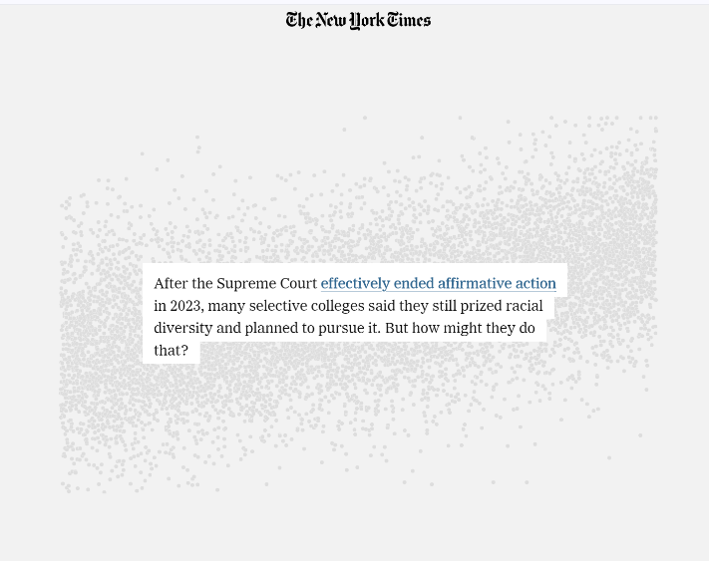Topic: <https://www.nytimes.com/interactive/2024/03/09/upshot/affirmative-action-alternatives.html>

Good afternoon, everyone. My name is Peiyuan Li. Today, our team is here excited to share a data visualization from The Upshot by The New York Times.

This visualization discusses the strategies colleges may implement to maintain a diverse community following the Supreme Court's effective termination of affirmative action in 2023.

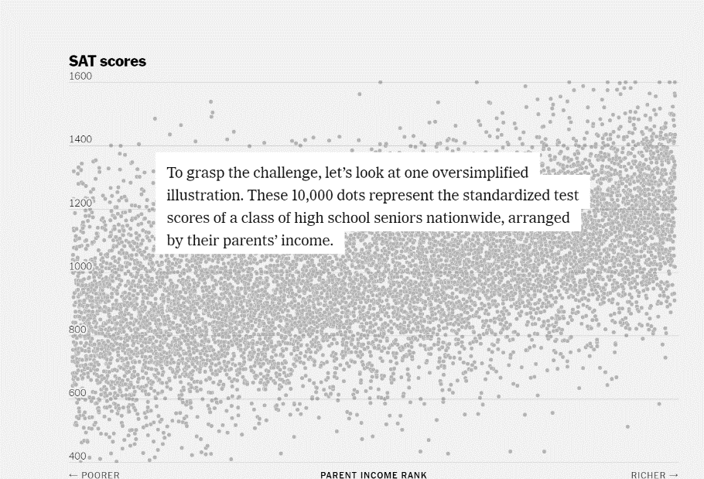Presented in web format, the visualization starts with a question and plotted data, which introduces the research target of this visualization.

Now, the author starts explaining the meaning behind the image. They present a straightforward view of the distribution relationship between SAT scores and levels of wealth. It’s an oversimplified illustration, but it serves as a powerful starting point for discussing equity in education later.

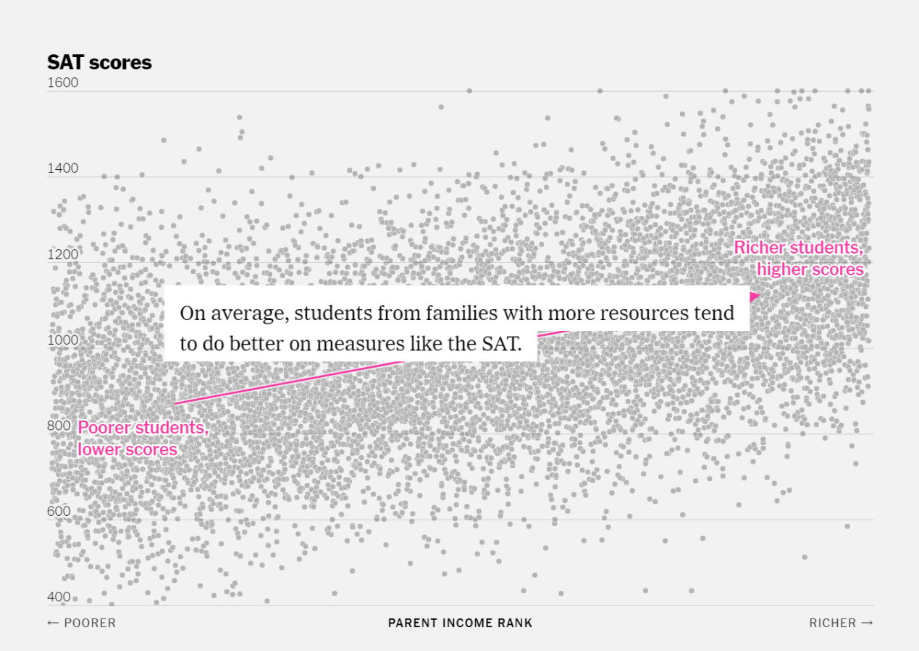

Next, the author introduces a new line. With the line, we can see a clear trend—the more income a student's family has , the higher their SAT scores tend to be.

Then in this graph, the author marks the data points representing Black and Hispanic students, adding another layer of analysis to the discussion of education equity. It brings forth the argument that admissions based solely on test scores may not be fair to these groups.

So, how severe the equity problem could be if we do not take any action after affirmative action is no longer legal? As demonstrated here, if colleges admitted students only based on an SAT score with a cutoff of, lets say 1300.

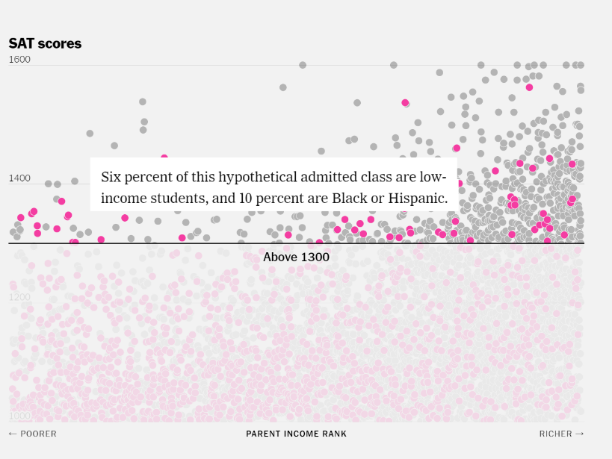

Only six percent of this hypothetical admitted class would be low-income students, and just ten percent would be Black or Hispanic. The number of low income, Black and Hispanic students would be minimal, placing them at a significant disadvantage.

This problem was solved by the affirmative action, just like this graph, colleges will admit more portion of minimal group students to ensure diversity.

However, the preferences are not legal after 2023; colleges must seek alternative solutions with such policies no longer legal.

For instance, admission officers could lower the cutoff score to admit more people. But we can observe it comes with a problem that a large number of students are admitted now, which may exceed the capacity of class size.

So, the author suggests adjusting the cutoff line slope to consider the wealth disparity, thus giving more opportunities to students from poorer backgrounds. Which also maintain original class capacity.

Or they could entirely rethink their admission criteria.

So far, through a step-by-step visualization process, the author has profoundly described why universities should find ways to solve the issue of diversity in admissions after affirmative action is no longer legal. This step-by-step revelation is both captivating and persuasive. We really like this storytelling mode, or narrative data visualization. It was a very immersive experience to explore some data, and it allowed us to logically follow the author's reasoning.

Let's go back to this graph. This is actually the author's final suggestion, which is to tune the academic cutoff with a wealth parity consideration. Instead of showing a final image and a lengthy explanation afterward, the author writes the logic step by step, which is very easy to understand and find where we agree or disagree.

In the second part, the author collaborates with Stanford University to conduct experiments, for four possible solutions. Since our focus today is on sharing the visualization rather than the solution, we will look at just the first proposed solution, as the others are similar in their present approach.

In this visualization, we found many visualization strategies that could be useful.

Narrative Structure: The visualization teaches us the power of storytelling with data. By walking us through a logical progression of insights, the narrative structure guides us to understand complex issues without overwhelming us with information. It's a reminder of how a well-crafted story can lead to a deeper understanding and a more engaging presentation.

Interactivity and Engagement: The dynamic nature of the visualization, which allows readers to scroll and uncover more data, greatly enhance engagement. It demonstrates that user interaction can lead to personal discovery and a more memorable learning experience.

Visual Simplicity and Clarity: Despite the complexity of the subject, the visual elements remain simple. Using colors and minimalistic graphics to represent different demographics exemplifies how visual simplicity can make complex data accessible and easily understandable.